The Dalles Dam Bird hazing program
– Avian Task Group Write-up
Prepared by: Bob Cordie
October, 2013

The Dalles History
The Dalles Dam bird abatement program has a long history of changes and trial/error. Originally USDA APHIS was contracted for 12 months a year to haze and/or lethally remove problem birds and mammals as needed from both The Dalles and John Day Dams. A large part of this program involved fish-eating birds which were lethally removed at all times of the year. The original hazing contract, prior to 1995, was 12 month/year. I changed it to 3.5 months for piscivorous bird abatement once we had some data to show the largest impact to juvenile salmonid passage. This was the only period to be funded through fish and wildlife funds. All other animal damage abatement activity would require another funding source. The original hazing contract also included very liberal lethal removal via shotguns. This was brought to FPOM attention and arbitrary changes were made to lethal limits several years later.
During this time we also focused on avian line arrays to determine the most effective locations. Bird data was collected by project Fishery Biologists to help determine the most vulnerable locations. Simultaneously we looked into alternative methods of abatement. This included falconry, remote control aircraft, sound, lasers, strobe lights, reflective items, balloons etc… all had limited effect, if any.
The most effective approach clearly seemed to be an avian line array, and full daylight hazing by boat. However boat hazing is very cost prohibitive.
Eagles
Overwintering bald eagles have increased dramatically at The Dalles over the past 5 years. We collaborated with the Fish Field Unit to study the potential effect of avian lines on eagle behavior. We concluded that the lines do not interfere with their feeding activity since they can find ample food just outside the array. Additionally they seem to see the locations of all the lines. Therefore our plan is to not add new lines, nor do we remove any existing lines.
Bigger Question
It’s obvious the gulls are there for juvenile fish, but Fish Field Unit studies have shown that they are not highly efficient predators. We tend to focus on the visible. We have an abatement system in place now, but how much more do we really need and at what cost, especially with the present federal budget status. Seems there may be better ‘bang’ (pun intended) for our buck on other locations and issues for salmon survival. I would like to see a predator effectiveness comparison to determine if gulls should be our predator focus or should we use our very limited funds elsewhere. Should we expand our pikeminnow control program? Should we address smallmouth bass removal?

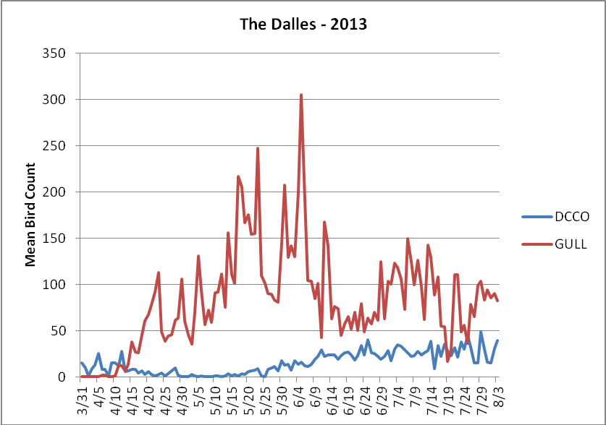

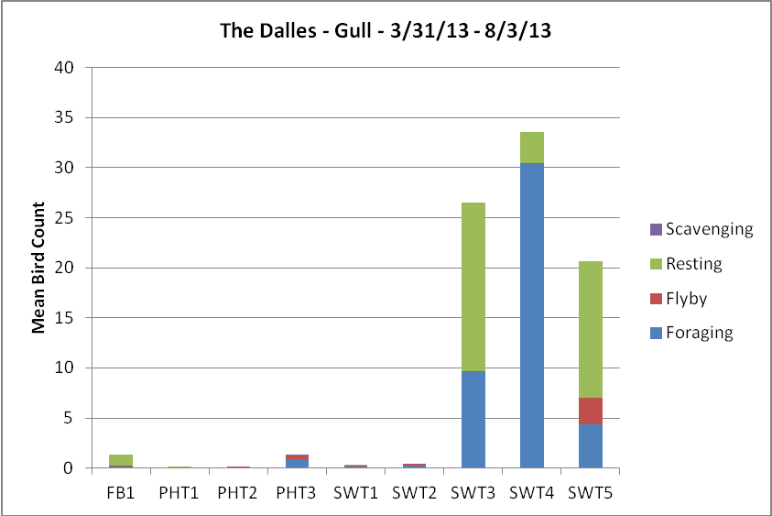
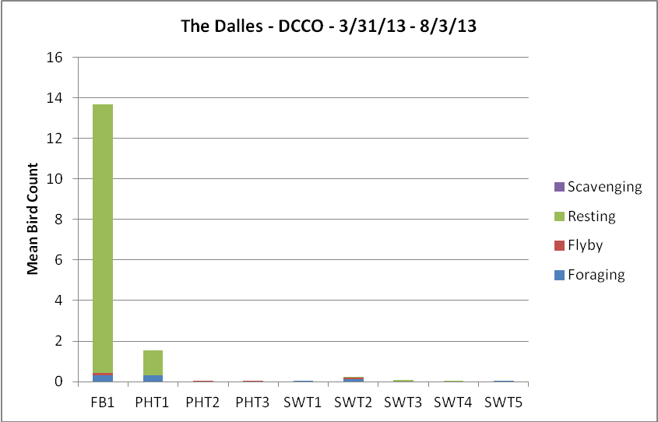

Prioritized Avian Predation Deterrent Alternatives
- Perform a study to compare predatory success of piscivorous birds and fish at The Dalles Dam, to determine predators and predation levels.

- Focus the appropriate amount of abatement to the appropriate amount of predation by each given species.

